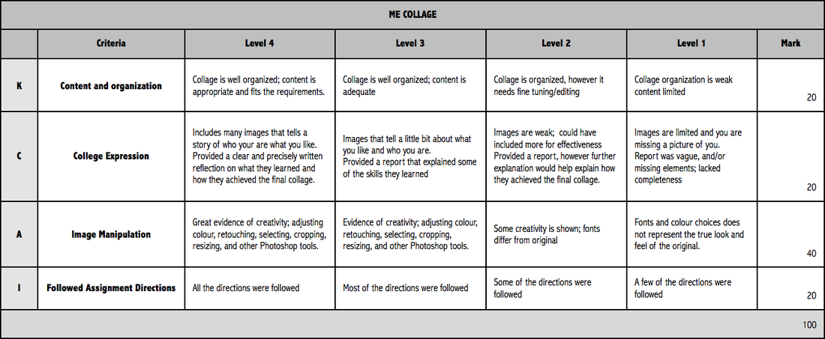

Jacob Riis took powerful pictures to convey a message to the general public. In this activity you will take powerful pictures of items, people, or events in your community to display a message you would like others to consider. It is easiest to use the Pixlr platform to layer images to increase the effectiveness of your message(s). Assignments will be submitted digitally to blackboard.

